Project-11
AI CALCULATOR
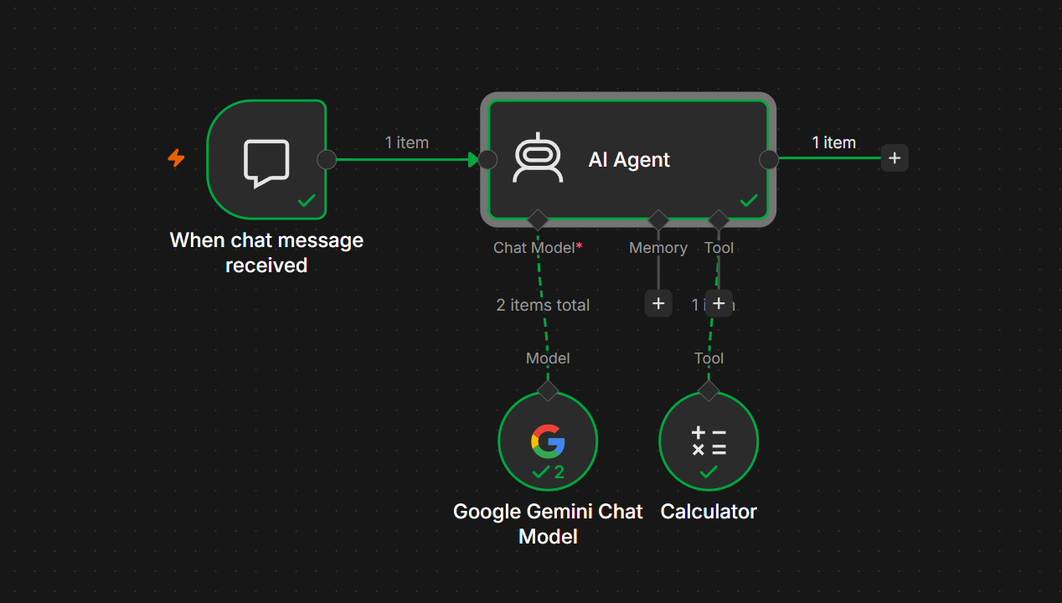
AI Calculator Agent in n8n – Documentation
Project Title
AI Calculator

Objective
The objective of this workflow is to create an AI-powered calculator that understands mathematical questions in natural language and uses the built-in Calculator Tool to perform accurate calculations instead of relying on the language model's internal reasoning.
Example user requests:
- What is 25 × 67?
- Calculate (450 + 700) ÷ 5
- What is the square root of 256?
- Find 15% of 2500

Workflow Architecture
When Chat Message Received
│
▼
AI Agent
├────────────► Google Gemini Chat Model
│
└────────────► Calculator Tool

Workflow Components
1. Chat Trigger
Node
When Chat Message Received
Purpose
This node starts the workflow whenever the user sends a message in the n8n chat interface.
Input
Natural language query.
Example:
What is 450 × 23?
Output
{
"chatInput":"What is 450 × 23?"
}

2. AI Agent
Purpose
The AI Agent receives the user's request, understands the intent, decides whether a tool is required, invokes the Calculator Tool, and returns the final answer.
Responsibilities
- Read user question
- Identify mathematical problems
- Call Calculator Tool
- Return accurate answer
- Avoid mental calculations

System Prompt
You are an AI Calculator.

Your job is to solve mathematical problems accurately.

Always use the Calculator Tool for calculations instead of performing mental math.

If the user asks a mathematical question, invoke the Calculator Tool.

Return only the final answer in a clear and concise manner.

If the question is not related to mathematics, politely respond that you only assist with mathematical calculations.

Source for Prompt
Connected Chat Trigger Node
Prompt:
{{$json.chatInput}}

3. Google Gemini Chat Model
Purpose
Acts as the Large Language Model (LLM) that understands natural language and determines when to use the Calculator Tool.
Configuration
Provider
Google Gemini
Example Model
Gemini 2.5 Flash
Authentication
Google AI Studio API Key

4. Calculator Tool
Purpose
Performs mathematical operations with precision.
Supported Operations
Addition
45 + 67
Subtraction
500 - 125
Multiplication
45 * 67
Division
500 / 8
Percentages
15% of 2500
Square Roots
sqrt(144)
Power
25^3
Complex Expressions
(450 + 670) / 12

Workflow Execution
Step 1
User types
What is 250 × 48?
↓
Step 2
Chat Trigger sends
chatInput
↓
Step 3
AI Agent receives
What is 250 × 48?
↓
Step 4
Gemini understands
"This is a mathematical problem."
↓
Step 5
AI Agent calls
Calculator Tool
↓
Step 6
Calculator returns
12000
↓
Step 7
AI Agent responds
The answer is 12,000.

Data Flow
User
│
▼
Chat Trigger
│
▼
AI Agent
│
├────────► Gemini Chat Model
│
└────────► Calculator Tool
│
▼
Final Response

Sample Inputs and Outputs
Example 1
Input
25 + 75
Output
100

Example 2
Input
456 × 987
Output
450072

Example 3
Input
(500 + 250) / 5
Output
150

Example 4
Input
sqrt(625)
Output
25

Example 5
Input
What is 18% of 9500?
Output
1710

Advantages
- Supports natural language queries.
- Produces accurate calculations using the Calculator Tool.
- Avoids arithmetic mistakes by not relying on the LLM alone.
- Simple workflow suitable for beginners learning AI Agents in n8n.
- Easily extensible with additional tools (e.g., Weather, Web Search, Google Sheets).

Error Handling
Error: No Prompt Specified
Cause: The AI Agent did not receive a user prompt.
Solution: Ensure the AI Agent is connected to the When Chat Message Received trigger and uses {{$json.chatInput}} as the prompt.

Error: Too Many Requests
Cause: The Google Gemini API rate limit has been exceeded.
Solution: Wait a few minutes before retrying or review your API quota in Google AI Studio.

Error: Calculator Tool Not Invoked
Cause: The Calculator Tool is not connected to the AI Agent.
Solution: Connect the Calculator node to the Tool input of the AI Agent.

Learning Outcomes
After completing this project, you will understand:
- How to build an AI Agent in n8n.
- How to connect an LLM (Google Gemini) to an AI Agent.
- How to integrate tools with an AI Agent.
- How the AI Agent decides when to use external tools.
- How prompts flow from a Chat Trigger to an AI Agent.
- How to test and debug AI Agent workflows.

Final Workflow
User
│
▼
When Chat Message Received
│
▼
AI Agent
┌────────┴────────┐
▼ ▼
Google Gemini Chat Model Calculator Tool
│ │
└────────┬────────┘
▼
Final AI Response
This AI Calculator is an excellent first AI Agent because it introduces the core n8n concepts you'll use in more advanced agents: triggers, AI models, tools, prompt handling, and workflow execution.

